The Austin Healey Club of WA (Inc) (AHC of WA) was formed in May 1967 by a group of Austin Healey enthusiasts. It is the oldest Austin Healey Club in Australia catering for both Sprites and Big Healeys in one club.

The club exists for the maintenance of Austin Healeys in all their forms and to encourage their use within Western Australia. To achieve this, we hold meetings and events at which members may participate to become more familiar with their vehicles and use them in the way for which they were created. This enthusiasm is used to promote, foster and conduct motor sport generally and to encourage a relationship with other clubs of similar interests.

As well as being a member of the Council of Motoring Clubs affiliated in Western Australia, The AHC of WA is a strong and active partner in the international group of Austin Healey Clubs that can trace their origins back to the first club that grew from the support of The Donald Healey Motor Company in 1955.

Annual gatherings of Austin Healey enthusiasts are held at Australian National Rallies hosted by individual state clubs. These are excellent opportunities to meet and further promote the strong fraternity that exists within the Austin Healey movement.

The club can offer members help in such matters as:
- Concessional vehicle licensing
- Insurance
- Parts
- Exchange of ideas and technical information
- Competition and social outings with fellow enthusiasts
- Monthly newsletter
- Australian Austin Healey magazine (4 issues per year)

The membership year extends from 1 July to 30 June. Club meetings with an informal atmosphere are held on the fourth Monday each month at the Veteran Car Club rooms at 265 Hale Road, (corner of Hale Road and Tonkin Highway), Wattle Grove commencing at 7.30 pm.

As our common interest is cars bearing the Austin Healey name, we look forward to seeing you at a future meeting or club event. Should you require any further information on the club or Austin Healeys in WA, please contact our Membership Secretary, Diane Cooper (H) 9457 0819 or (M) 0408 916 512 email: dcooper@iinet.net.au.

On the following page of this information sheet is a membership application. Here we require information about you and also about your Austin Healey(s).

Paul Robertson
President

Mobile: 0427 412 136
Email: probertson041@gmail.com

Member(s) details
Membership number: |  |  |  |  |  | Office use only
Applicant (1) name: |  |  |  |  |  | Date of birth: |  |  | / /
Applicant (2) name: |  |  |  |  |  | Date of birth: |  |  | / /
Address:
 |  | Suburb/  Town: |  |  |  |  | Postcode:
Email addresses: |  | (1) |  |  | (2)
Telephone numbers: |  | Home: |  | Home:
 |  | Mobile: |  | Mobile:
 |  | Work: |  | Work:
 | Type of membership
 | I/We hereby make application for membership and agree to abide by the Constitution and By-laws, as set out from time to time, by the Club or its Executive Committee. I/We also agree to comply with the conditions of Concessional registration if applicable to me/us.

Applicant (1) signature: |  | Date: | / /
Applicant (2) signature: |  | Date: | / /

1. |  | Membership Category (compulsory) | Select as required
 |  | Metro double – 2 persons living within Perth metro area | ☐ | $75.00
 |  | Metro single – 1 person living within Perth metro area | ☐ | $65.00
 |  | Country – 1 or 2 persons living outside Perth metro area | ☐ | $50.00
2. |  | The Australian Austin-Healey magazine 4 issues including postage within Australia (optional) | ☐ | $30.00
 |  | Total payment submitted: |  | $
 | How to pay
- Electronic Funds Transfer (EFT) and email form: (Preferred Option)
Direct transfer to the Austin Healey Club of WA (Inc): BSB 036 065, Account 130 601
(include your Surname and the word ‘Fees’ as your identification) and email the completed form to the Treasurer at treasurer@austinhealeywa.org.au or

- Cheque and post form:
Post your cheque made out to the Austin Healey Club of WA (Inc) with the completed form to the Club’s postal address at:
The Treasurer
Austin Healey Club of WA (Inc)
PO Box 70
Maylands WA 6931

About your car(s) (as per the licence paper)
Full name on Licence/  Registration papers: | 1. |  | 2.
Make of vehicle(s): | 1. |  | 2.
Model/Series/Year: | 1. |  | 2.
Year: | 1. |  | 2.
Registration number: | 1. |  | 2.
Colour(s): | 1. |  | 2.
Chassis number: | 1. |  | 2.
Engine number: | 1. |  | 2.
Body number: | 1. |  | 2.
Modifications: | 1. |  | 2.
Previous registration and ownership details (if known)
Owners name(s): | 1. |  | 2.
Address: | 1. |  | 2.
Suburb/Town:
Postcode:
Registration number(s): | 1. |  | 2.
Colour(s): | 1. |  | 2.
History: | 1. |  | 2.
Modifications: | 1. |  | 2.
Spare parts: | 1. |  | 2.

Please supply if possible 3 photos:

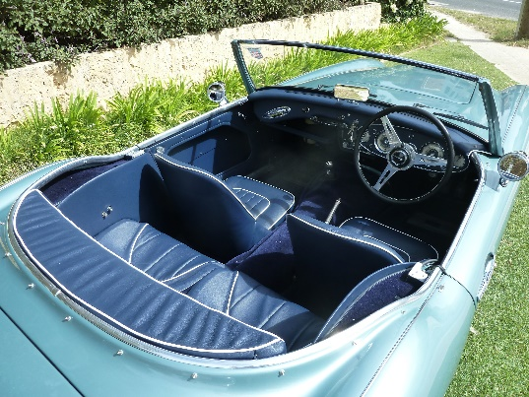
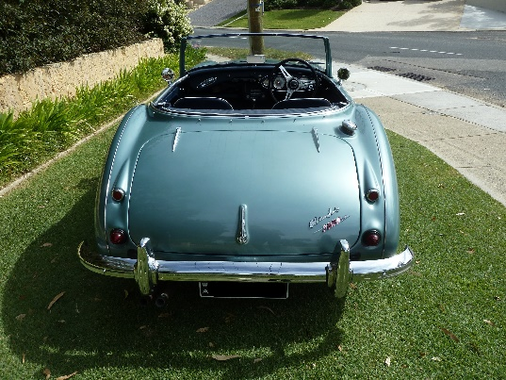
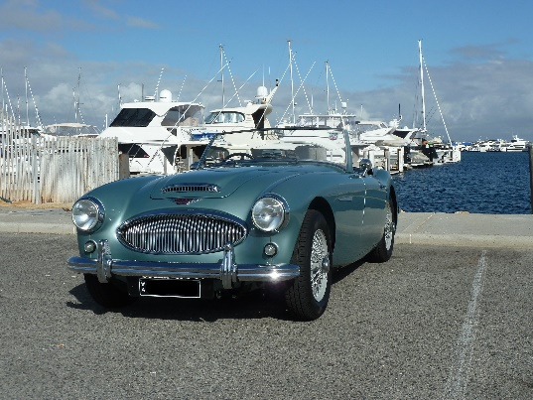
One photo showing the front and side view together (a ¾ view), one photo of the rear view, and one photo of the interior, as per the examples below:

